**PROJECT REPORT**

**DREAM HOMES REALTY**

**Team leader: M. Aarthi**

**Team members: J. Asha**

**J. Divya**

**S.D. Barathi**

**Project Title: Dream homes realty(construction)**

**INTRODUCTION**

Dream Homes Realty, a construction company, uses Zoho Books to track project expenses, manage subcontractor payments, and handle invoicing. They can generate estimates and invoices for clients, track job costing, and monitor the profitability of each project. Zoho Books provides them with financial insights to make informed decisions

1.2 Purpose

In simple term, a project is a sequence of the related tasks and activities that help me create something new or change an existing product, service, or organization.

**PROBLEM DEFINITION &DESIGN THINKING**

2**.**1 Empathy map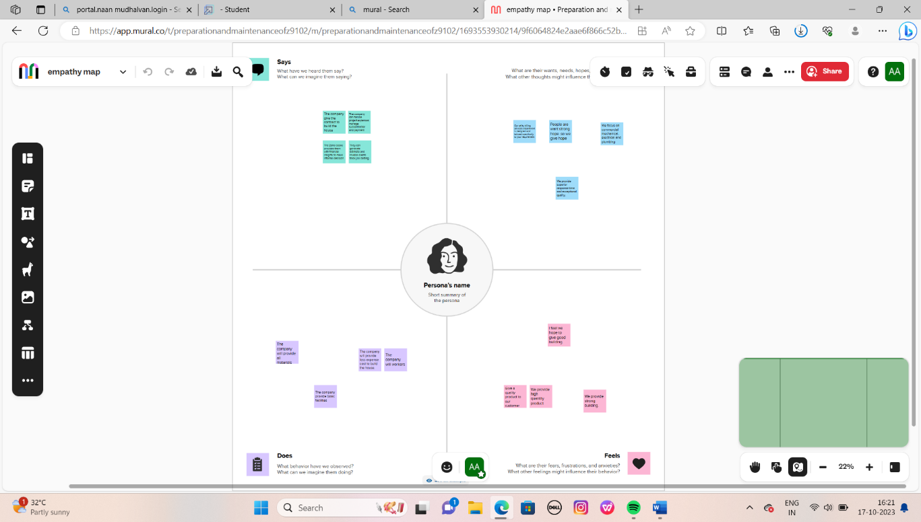

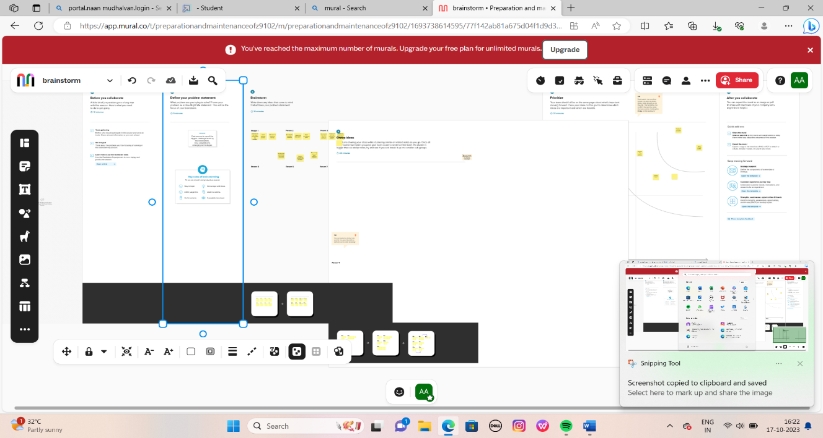

**3 RESULTS**

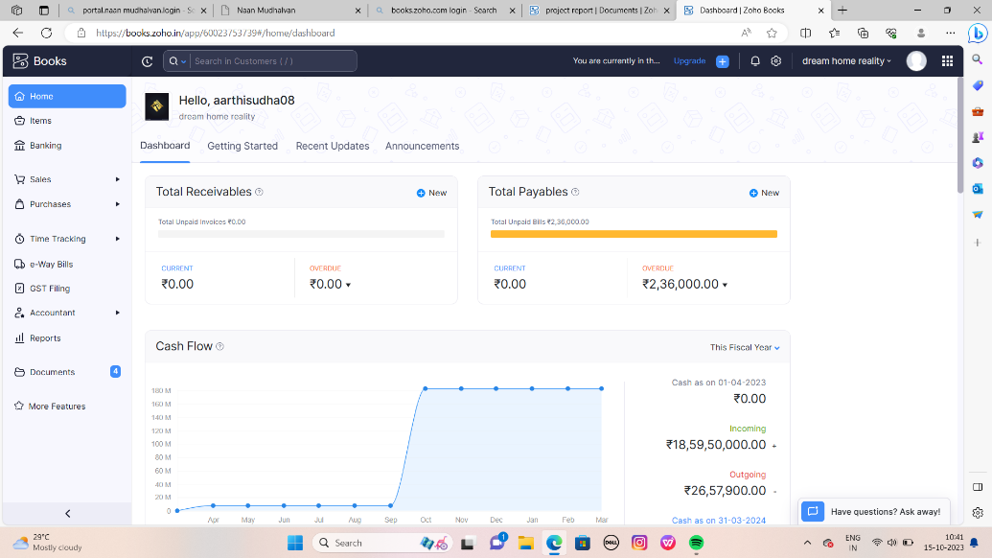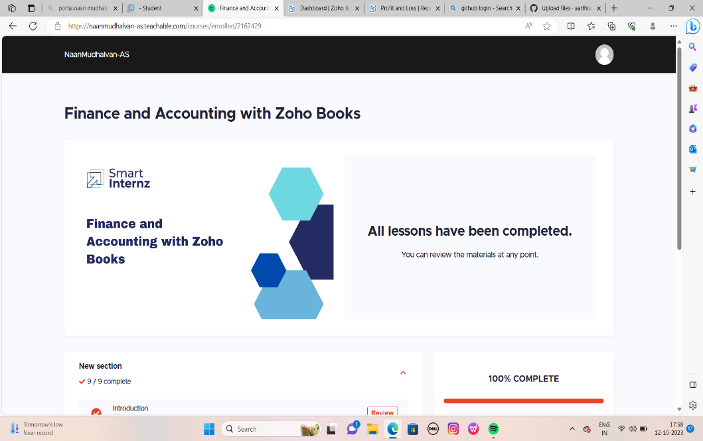

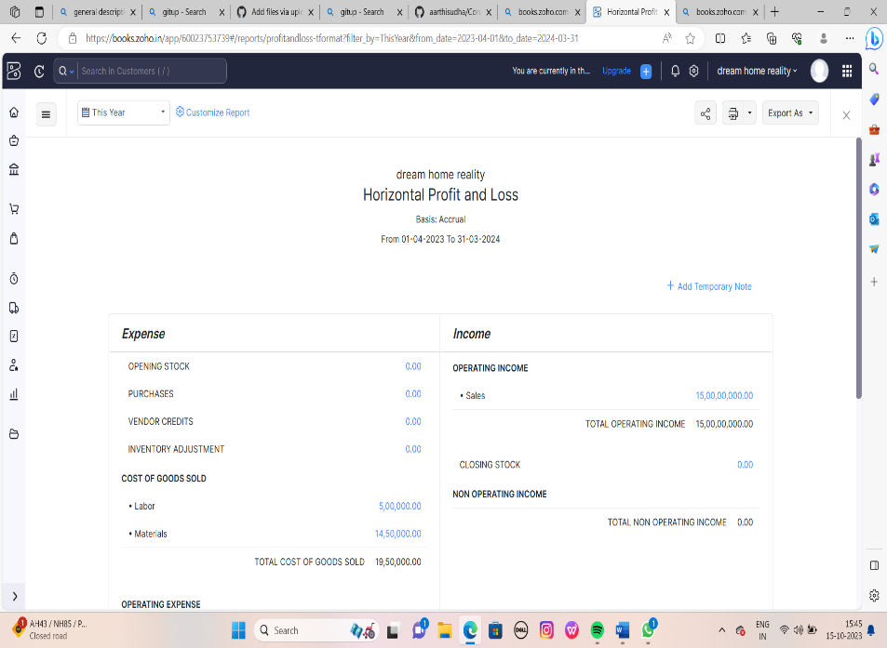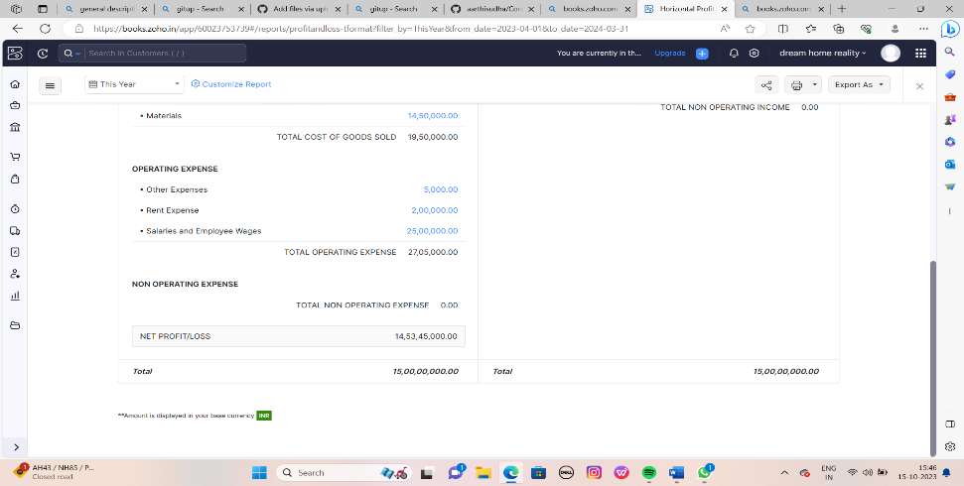  **ADVANTAGES**

1. Cost-effectiveness
2. Feasibility
3. Improved focus
4. Identifying new opportunities
5. Providing valuable information
6. Narrowing business alternatives

**DISADVANTAGES**

* Poor productivity due to various issues such as design errors, planning oversights, and material shortages.
* Rising cost of materials and project overruns.
* Poor project performance and quality.
* Skilled labour shortages and low salaries.
* Serious long-term health issues from physical work and exposure to hazards.
* Delay in occupancy and risk of losing job of the contract.

**APPLICATION**

1. [Zoho Books is an online accounting software that helps businesses manage their finances, automate workflows, and collaborate across departments](https://www.zoho.com/books/) .
2. Smartintenz app help to learn the project and this app provide the workspaces about the project.
3. Getup app help upload the project.

**CONCLUSION**

A project is very useful for students in zoho books we learn how to maintain a company and the we learn about the process of the company.

Future scope

In future we want more advantages and advanced methods to work with a application. Second level more development we want.